Planning Commission
Martin Memorial Hall
5259 Route 5, Ascutney VT
Planning Commission Meeting Minutes
Monday, February, 8, 2021 7:00 PM

Planning Commission Members Present:
Paul Tillman
Howard Beach
Michael Todd
Tyler Harwell
Chris Whidden, Zoning Administrator

Online Attendees: Brandon Gulnick, Town Manager, Gary Rapinotti
- Call to Order by Chair, Paul Tillman at 7:00 pm

- Agenda Review – January,25, 2021

#6 was added to the agenda
Memo from Chris Whidden was added to the agenda at #7

The new agenda would be as follows:

- Call to Order
- Agenda Review – 8 February 2021
- Comments from the Chair and Land Use Administrator
- Comments from Citizens regarding items not on the agenda
- Approval of Meeting Minutes – January 25, 2021
- Hearing of adoption of 2017 Future Land Use Map as the current zoning map; with definitions.
- Subdivision regulation amendment
- Discussion 2017 Future Land Use definitions/zoning districts
  - Industrial
  - RR1
  - Perkinsville Village area
- Discussion for Items for Future Agendas
- Any other business that can be legally discussed
- Adjourn

- Comments from Chair and Land Use Administrator

Paul Tillman let the Planning Commission know that he received an official resignation from Fred Kowalik. This will be forwarded to the Select board for acceptance and to find someone to full the seat.

Chris Whidden wanted to make the Planning Commission aware he would not be available Tuesday, February 9th, Thursday, February 11th and March 1st.

February 11, 2021 Chris Whidden has 2 ZBA hearings: Variance at Grace Drive and Earth ext.
February 25^{th,} he has a hearing for a hotel.

- Comments from Citizens regarding items not on agenda.

No comments from Citizens.

- Approval of Meeting Minutes 2-8-21

Tyler Harwell made motion to approve minutes from 2-8-21.
Michael Todd - 2nd
No discussion
Vote – unanimous
- Hearing on adoption of 2017 Future Land Use Map as the current Zoning Map, with definitions.

Paul Tillman opened the hearing at 7:09 PM

NOTICE OF PUBLIC HEARING

In accordance with the provisions of 24 V.S.A. §§ 4441(d) and 444, of the Vermont Statutes Annotated, and in consideration of the stay at home guidelines in STATE OF VERMONT EXECUTIVE DEPARTMENT ADDENDUM 6 TO EXECUTIVE ORDER 01-20 with respect to the timing of public hearing, the Planning Commission for the Town of Weathersfield, Vermont, will hold a public hearing on Monday, February 8, 2021, at 7:00 PM., in the Weathersfield Town Office, at 5259 Route 5 in Ascutney, Vermont, to hear public comments on the adoption of proposed Zoning Map and Bylaw amendment begin considered by the Planning Commission.

Statement of Purpose

The Planning Commission has voted to hold a hearing regarding the adoption of the 2017 Future Land Use Map and definitions as the current Land Use map and definitions.

Geographic Areas Affected

The entire Town of Weathersfield is affected by this amendment.

Sections Headings

The proposed Zoning Bylaw amendments would allow for the development of the Town in accordance with the Town Plan.

Persons withing to be heard may do so in person, via remote attendance, be represented by an agent, or may file written comments with the Planning Commission prior to hearing.

Dated at Town of Weathersfield, Windsor County, State of Vermont, this 12th day of January, 2020.
Paul Tillman, Chair
Weathersfield Planning Commission

Chris Whidden completed the Planning Commission Reporting Form for Municipal Bylaw Amendments.

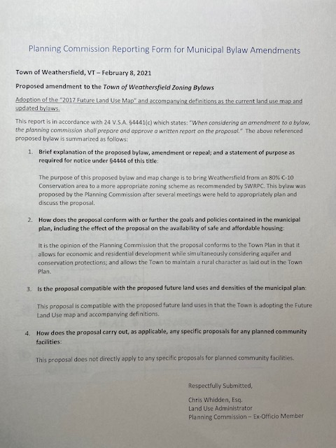

Michael Todd made a motion to accept the Planning Commission Reporting Form.
Howard Beach – 2nd
No Discussion
Vote – Unanimous

After some additional discussion

Tyler Harwell made a motion to continue the Planning Commission Form for Municipal Bylaw Amendments to the next Planning Commission Meeting 2-22-21.
Michael Todd – 2nd
No Discussion
Vote – unanimous

- Subdivision regulation amendment proposal

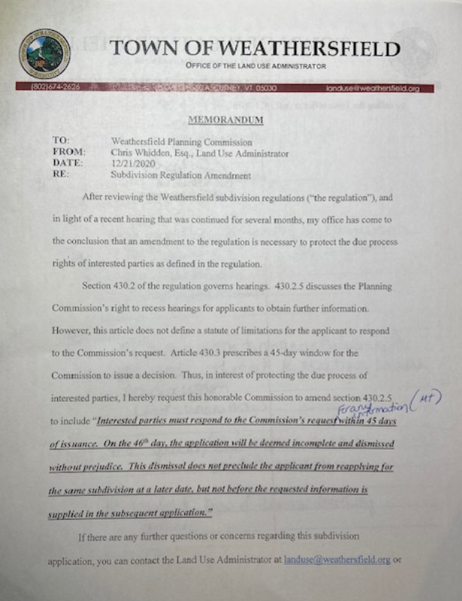

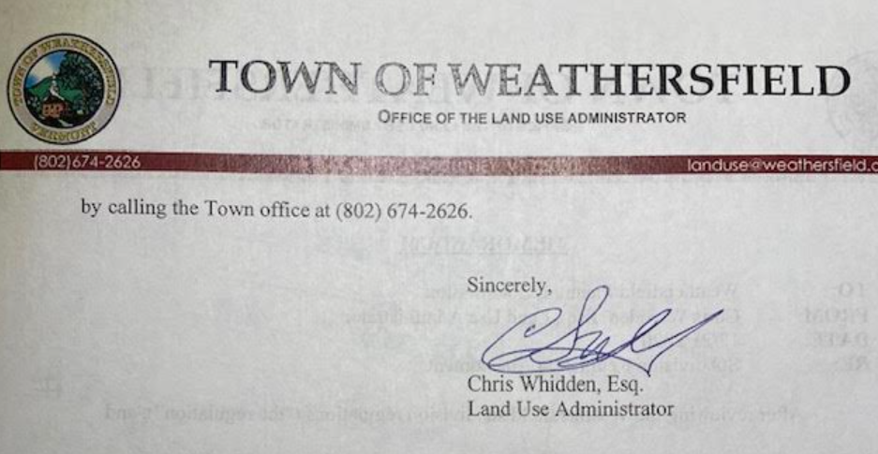

Michael Todd suggested that “for any information” be added to “Interested parties must respond to the Commission’s request for any information withing 45 days of issuance. On the 46th day, the application will be deemed incomplete and dismissed without prejudice. This dismissal does not preclude the applicant from reapplying for the same subdivision at a later date, but not before the requested information is supplied in the subsequent application.”

Michael Todd made a motion to add amendment with changes as submitted.
Chris Whidden – 2nd
No further discussion
Vote – unanimous

- Discussion 2017 Future Land Use definitions/zoning districts
  - Industrial
  - RR1
  - Perkinsville Village area

Further discussion was had on the Land Use definitions and zoning districts.

Tyler Harwell brought up zoning some zoning districting of river frontage properties and questions that may arise from these areas.
Definitions with updates as follows:

Industrial (I) 2/8/2021
Purpose: Areas suitable in terrain and proximity to transportation facilities to be desirable by industry and those commercial activities that do not depend on highway traffic for customers. Provides employment for local residents and broadens the Town tax base. Currently located in areas partially so developed and considered to be appropriate for such use.
Uses that do not require a Zoning Permit: The following uses are permitted without a Zoning Permit, provided that these uses are in compliance with these Bylaws:
- Agriculture/Forestry
Permitted Uses: The following uses are permitted following the issuance of a Zoning Permit by the Administrative Officer:
Permitted Principal Uses:
- Public water, sewage treatment plant1,2,3
- Self-Storage Facility1,2,3
- Auto salvage/recycling facility, landfill, recycling facility (privately owned)1,2,3
- Industrial1,2,3 (see definition)
- Non-highway Commercial1,2,3 (see definition)
- Wireless Communication Facilities2,3

Permitted Accessory Uses:
- Accessory use or structure
- Athletic Courts/ Outdoor recreation facility (only as facilities for use by employees during lunch, etc. on same basis as primary industrial commercial facility)
- Home occupations (for existing homes)
- Small Office (see definition)

Conditional Uses:
The following uses are permitted upon the granting of Conditional Use Approval by the Board of Adjustment:
Conditional Principal Uses:
- Extraction of earth resources1,2,3
- Highway Commercial
- Home industry (for existing homes)
- Other uses (as determined after public hearing, by the Board of Adjustment, to be of a similar type and character as those listed above and meeting the purposes of this District)

Conditional Accessory Uses:
Uses Not Permitted: The following uses are not permitted within this District:
- Adult day care facility
- Campground, resort, children’s camp
- Cemetery
- Community Non-profit
- Gasoline/service station
- Indoor recreational facility
- Inn/small hotel
- Medical facility (see definitions)
- Mobile home park
- Multi-family dwelling
- Residential PUD
- School (see definition)
- Single family dwelling
- Two family dwelling

- Discussion of Items for Future Agendas
Continue discussion on the following:
  - Industrial
  - RR1
  - Perkinsville Village area
Overview by Howard Beach to present Guide Vermont in enabling better places.

- Any other business that can be legally discussed
None

- Adjourn
Tyler Harwell made a motion to adjourn the meeting.
Howard Beach– 2nd
No discussion
Vote - unanimous
Meeting adjourned at 8:58 PM
Next Planning Commission Meeting is scheduled for Monday, February 22, 2021 at 7:00 pm at Martin Memorial Hall.

Respectfully,
Chauncie Tillman
Recording Secretary

Planning Commission
__________________________  Paul Tillman, Chair | ____________________________  Howard Beach, Vice Chair
_________________________
Tyler Harwell, Commissioner
__________________________

Michael Todd, Commissioner

