Planning Commission
Martin Memorial Hall
5259 Route 5, Ascutney VT
Planning Commission Meeting Minutes
Monday, May 10, 2021 6:30 PM

Planning Commission Members Present:
Paul Tillman
Tyler Harwell
Michael Todd
Howard Beach
Chris Whidden, Zoning Administrator

Attendees: Gary Rapinotti

Online Attendees: John Bonetti, AJ LaRose, Mary Anne Danielson, Georgia Burman, Sophie B, David Fuller

- Call to Order by Chair Howard Beach at 6:30 pm

- Agenda Review – May 10, 2021
No changes at this time.
- Comments from the Board and Land Use Administrator

Chris Whidden let the Planning Commission know that Jason Rasmussen will be attending the next meeting.

- Comments from Citizens regarding items not on agenda.

None

- Approval of Meeting Minutes 3-22-21

Michael Todd made a motion to accept the minutes of 3-22-21
Paul Tillman – 2nd
No Discussion
Vote - unanimous

- Hearing on Subdivision Regulation Amendment Proposal re: Statute of Limitation for Open Subdivision Hearings

Chris Whidden provided the following memo to the Planning Commission on 12-21-20:

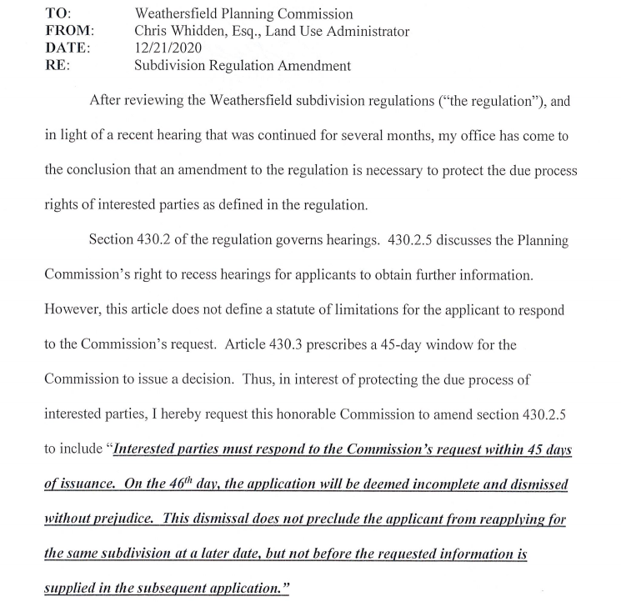

There were no changes to the proposed Amendment and the original hearing was scheduled for April 12, 2021.
Due to the meeting not being properly warned the hearing was continued to 5-10-21.

Tyler Harwell called a point of order as this was a public hearing and needed to be closed prior to moving on.
We need to close the hearing first.
Howard Beach asked if there was anyone online that would like to make a comment.
No comments.
Howard Beach closed the public hearing.

Michael Todd made a motion to adopt the language to include “…the Commission’s right to recess hearing for applicants to obtain further information” and “…prescribes a 45-day window for the Commission to issue a decision.”
Howard Beach – 2nd
No further discussion
Vote - unanimous

- Hearing – Drumlin Road Subdivision

Notice of public hearing for a Subdivision Application hearing for Monday, May 10, 2021 at 6:30 pm. The application of John Bonetti’s proposal to subdivide his 40.39-acre property, # 11-02-04 at Drumlin Road, Perkinsville, VT into 4 lots of 5.61 acres, 5.46 acres, 7.0 acres and 22.32 acres.
The lot is zoned as Residential 1. No structural developments are part of this application only division of the land into the mentioned 4 lots.
In accordance with 24 V.S.A §4464A.1 and 4463 and the Town of Weathersfield Subdivision Regulations, the Town of Weathersfield Planning Commission will hold a public hearing to consider the subdivision application and sketch plan review for this project.

One of the main concerns of this subdivision was a legal issue with the road and right of way. AJ LaRosa, Attorney commented that this issue was a separate issue and should not be considered in this application review.

Per Chris Whidden there is no right of way for the Town in this subdivision. This is just for the division of the parcel into 4 lots, nothing to do with the road or the right of way.

Paul Tillman noted that he wanted to make sure that if these lots were subdivided that they would all have access to the road.
There is a deeded right of way regardless if it is a Town Road.

Per Chris Whidden he reviewed the sketch plan and had his questions answered by Mr. Rapinotti. He does not need any further information on his end for this subdivision.

No additional comments, emails or phone calls were received regarding the subdivision.

Howard Beach closed the hearing for the subdivision at Drumlin Road.

Tyler Harwell made a motion to approve the subdivision.
Paul Tillman – 2nd with the amendment for the motion to include the name and the place.
Tyler Harwell revised his motion to approve the application of one Mr. John Bonetti to subdivide 40.39 acre parcel of property #11-02-04 on Drumlin Road in Perksinville, VT pursuant to the notice of hearing for Monday, May 10, 2021.
Paul Tillman – 2nd
No further discussion
Vote - Unanimous

- Discussion 2017 Future Land Use definitions/zoning districts
  - Industrial – done, see mark ups
  - RR1 – See changes:
Rural Residential (RR–1) (Updated changes from 3/22/2021 meeting) 3/22/2021
Purpose: Residential growth areas surrounding villages and hamlets; somewhat convenient to their amenities.
Uses that do not require a Zoning Permit: The following uses are permitted without a Zoning Permit, provided that these uses are in compliance with these Bylaws:
- Agriculture/Forestry (See State law statues for Forestry)
- Home-based occupation
- Minor structures (see definition)
- Temporary signs
Permitted Uses: The following uses are permitted following the issuance of a Zoning Permit by the Administrative Officer:
Permitted Principal Uses:
- Cemetery
- Home-based business, level 1
- Single family dwelling
- Two family dwelling
Permitted Accessory Uses:
- Accessory dwelling unit
- Accessory use or structure
- Adult day care service
- Baby-sitting service
- Athletic courts
- Bed and Breakfast (up to 3 bedrooms for transient boarders/tourists)
- Family child care home
- Ponds
- Seasonal roadside stand
- Signs, permanent
- Swimming pool (in ground or above ground)
Conditional Uses: The following uses are permitted upon the granting of Conditional Use Approval by the Board of Adjustment:
Conditional Principal Uses:
- Multi Family dwelling(3 to 4 Families)
- Adult day care facility1,3
- Airport uses (as allowed only under Section __)??mixed use??
- Campground, resort, children’s camp1,3
- Church (see Community Non-profit)
- Community Non-profit1,2,3 (Primarily nonprofit: church, museum, library, private club, YMCA, YWCA, mortuary, etc.)
- Family child care facility1,3
- Home-based business, level 2
- Indoor or outdoor recreation facility1,2,3 (see definition)
- Inn/small hotel1,3 (see definition)
- Medical facility1,2,3 (see definition)
- Extraction of earth resources1,2,3
- Mobile Home Park
- Public water, sewage treatment plant1,2,3
- School1,2,3 (see definition)
- Other uses (as determined after public hearing, by the Board of Adjustment, to be of a similar type and character as those listed above and meeting the purposes of this District)
- Small enterprise

Conditional Accessory Uses:
- Docks
- Wireless Communication Facilities2,3
Uses Not Permitted: The following uses are not permitted within this District:
- Contractor’s storage (of materials, machinery, heavy equipment)
- Gasoline/service station
- Highway Commercial Industrial
- Junkyard, landfill, recycling facility (privately owned)
- Multi-family dwelling
- Non-highway Commercial
- Self-Storage Facility (effective July 9, 2012)
Area, Land, & Structural Requirements:
- Only one principal use is allowed per parcel of land.
- Each principal use requires at least the minimum lot area and minimum required frontage specified for the district in which it is located.
- Establishment of multiple separate principal uses on a single parcel of land requires a PUD permit.
Soil or terrain conditions may require larger lot sizes to satisfy Town or State public health regulations; the burden of proof of soil suitability and terrain is on the applicant. Standards for soil suitability are available from the Soil Conservation Service.
Lot Area Minimum: 1 acre

Lot Frontage and Setbacks:
Frontage 120 feet
Front Setback 25 feet
Rear Setback 25 feet
Side Setback 15 feet

Building Heights:
Maximum Building Height: 35 feet. See “Height” definition for measurement standards.

c.) Perkinsville
d.) Airport
e.) RRR 3-5

**C, D and E pending updated changes from Chris Whidden from meeting 5-10-21**

- Discussion of items for Future Agendas

Further Airport discussion.

- Any other business that can be legally discussed
None

- Adjourn
Tyler Harwell made a motion to adjourn the meeting.
Michael Todd– 2nd
No discussion
Vote - unanimous
Meeting adjourned at 8:24 PM
Next Planning Commission Meeting is scheduled for Monday, May, 24, 2021 at 6:30 pm at Martin Memorial Hall.

Respectfully,
Chauncie Tillman
Recording Secretary

Planning Commission
__________________________  Paul Tillman, Chair | ____________________________  Howard Beach, Vice Chair
_______________________________
Tyler Harwell, Commissioner
__________________________

Michael Todd, Commissioner

